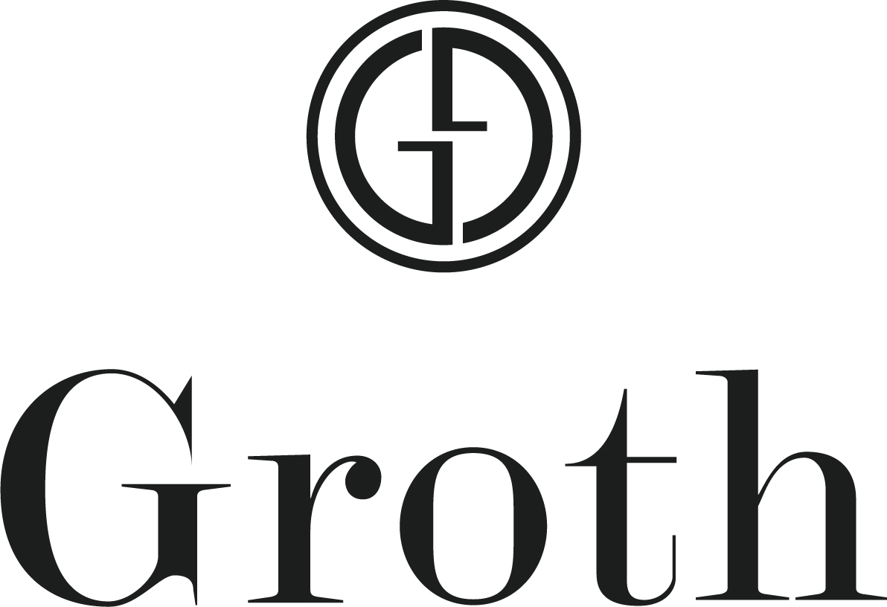

PRICE LIST

Current Release Wines

2019 Sauvignon Blanc, Napa Valley
$24.00 Retail
$20.40 Groth Wine Society

2018 Chardonnay: Hillview Vineyard, Napa Valley
$35.00 Retail
$29.75 Groth Wine Society

2016 Cabernet Sauvignon, Oakville
$65.00 Retail
$55.25 Groth Wine Society

2016 Reserve Cabernet Sauvignon, Oakville
$150.00 Retail
$127.50 Groth Wine Society

Current Release Large Format Wines

2016 Reserve Cabernet Sauvignon, Oakville 1.5L Magnum
$300.00 Retail
$255.00 Groth Wine Society

2016 Reserve Cabernet Sauvignon, Oakville 3L
$615.00 Retail
$522.75 Groth Wine Society

2016 Cabernet Sauvignon, Oakville 1.5L Magnum
$130.00 Retail
$110.50 Groth Wine Society

2016 Cabernet Sauvignon, Oakville 3L
$275.00 Retail
$233.75 Groth Wine Society

Library Reserve Wines

2014 Reserve Cabernet Sauvignon, Oakville
$155.00 Retail
$131.75 Groth Wine Society

2011 Reserve Cabernet Sauvignon, Oakville 1.5L Magnum
$340.00 Retail
$289.00 Groth Wine Society

Library Wines

2005 Cabernet Sauvignon, Oakville
$115.00 Retail
$97.75 Groth Wine Society

“Oakville Collection” Two bottles each of 2011, 2012, 2013
$475.00 Retail
$403.75 Groth Wine Society
Oakville Cabernet Sauvignon in Groth Wooden Box

Please inquire about additional library vintages & large format offerings

Groth Wine Society:
The Groth family of wine clubs.
Ask your host for more details.

We Are Unable to Ship to:
AL, IN, KY, LA, ME, MS, UT, WV, WY

